COMP1787 - Guidelines

Author: Vinh Hoang

**Lưu ý:**

**Tuyệt đối KHÔNG copy - paste/paraphrase từ bất cứ nguồn nào (sách, Website, bài sample, bài của người khác …) để không vi phạm quy chế đạo văn. Tất cả bài viết đều TỰ VIẾT dựa trên sự hiểu và kiến thức của bản thân.**

**Trường hợp bị phát hiện đạo văn nghiêm trọng trên TurnItIn thì không ai (kể cả trường hay Giảng viên) có thể giúp được.**

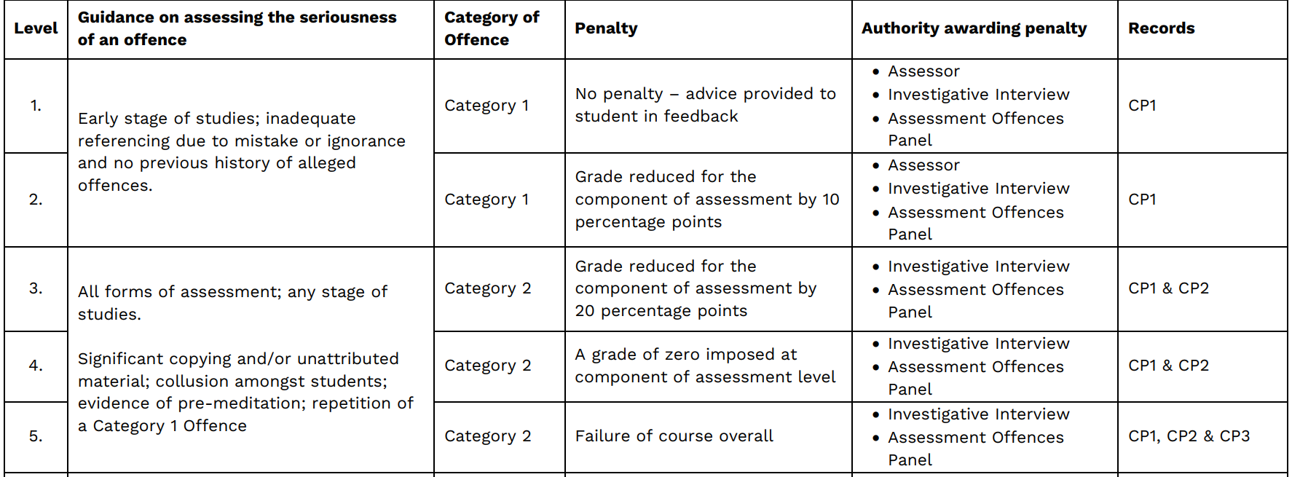

|  |
| --- |
| **Section A – Management Summary (20% of the marks)**  The case study tells us that the Management Director has decided to recommend one of the approaches associated with Agile Methods to the team of Agility Concepts. The Agile Method that they would prefer would be SCRUM with Agile.  Produce a management summary explaining whether SCRUM with Agile concepts an appropriate method would be to use for the project. Outline any advantages/drawbacks that you perceive. Give examples from the Case Study to support your answer.  Some criteria you should present in your report (less than 1000 words for this section):   * Give out concept, characteristic, advantages/disadvantages about Agile method, how and which kind of projects to apply Agile * Introduce some methods in Agile concept: SCRUM/RAD/DSDM (concept, characteristic, advantages/disadvantages about Agile method, how to apply). * Compare them by using the alternative matrix to support the Director manager idea (about apply SCRUM with Agile in TOG project). * Use some others case study you know to support this conclusion. |

For Section A, you will have to understand deeply Agile Mindset and Scrum framework. In order to do that, you have to read following books and documents:

[Scrum Guide | Scrum Guides](https://www.scrumguides.org/scrum-guide.html)

<https://www.scrumguides.org/docs/scrumguide/v2020/2020-Scrum-Guide-Vietnamese.pdf>

[Scrum Primer - Short Introduction to Scrum](https://scrumprimer.org/en/)

[vi_scrumprimer20.pdf](https://scrumprimer.org/primers/vi_scrumprimer20.pdf)

[Scrum and XP from the Trenches - 2nd Edition (infoq.com)](https://www.infoq.com/minibooks/scrum-xp-from-the-trenches-2/)

[Scrum va XP tu nhung chien hao (hanoiscrum.net)](https://hanoiscrum.net/hnscrum/images/resource/kniberg%20-%20scrum%20va%20xp%20tu%20nhung%20chien%20hao.pdf)

[Dự Án Phượng Hoàng - The Phoenix Project | Tiki](https://tiki.vn/du-an-phuong-hoang-the-phoenix-project-p56020644.html)

[Manifesto for Agile Software Development (agilemanifesto.org)](https://agilemanifesto.org/)

[The 4 Values and 12 Principles of the Agile Manifesto (smartsheet.com)](https://www.smartsheet.com/comprehensive-guide-values-principles-agile-manifesto)

[Principles behind the Agile Manifesto](https://agilemanifesto.org/principles.html)

Then, you will have to review the case study and use your knowledge, skills to perform required task.

You have to write YOUR OWN WORD and DO NOT COPY ANY PARGRAPH

|  |
| --- |
| **Section B – High level requirements analysis and MoSCoW prioritisation (30% of the marks)**  Table 1 of the case study provides details of a Facilitated Workshop session run by the Agility Concepts consultants and attended by a number of the key staff in the organization of Touch of Glass(TOG). |

|  |  |  |  |
| --- | --- | --- | --- |
| **ID** | **Requirements** | **Priority** | **Days** |
| **1** | Customers must be able to register and log in. However, it would be great if we could already create accounts for customers we know about and e-mail them their usernames and passwords. | **High**  **FR**  **Must have** | **3** |
| **2** | Customers must be able to search and browse different products, whether they are logged in or not | **High**  **FR Should have** | **5** |
| **3** | The look and feel of the website should be well designed and showcase the products well. I also want there to be rotating 3D views of the products. | **Low**  **FR**  **Wont have** | **3** |
| **4** | People should be able to contact us for bespoke items and the system should facilitate communication with them, including messages and sending pictures. | **High**  **FR Could have** | **6** |
| **5** | People should be able to sign up for glassblowing classes. | **Low FR** | **8** |
| **6** | The site must load quickly. | **Low FR** | **3** |
| **7** | As a Customer I want a choice of delivery slots so that I can arrange my diary appropriately. | **Low FR** | **5** |
| **8** | As the Operations Manager there needs to an ability to track an item’s lifecycle, from where the order is placed, up to the point where customers sign for the item they receive. Alerts should be sent to people in different phases of the lifecycle, like notifications for a job. | **Low**  **FR** | **5** |
| **9** | As the Operations Director I want to gather statistics on item popularity | **Low FR** | **5** |
| **10** | As a Customer I want to choose whether or not I am sent marketing information so that I do not get loads of junk mail. | **Low FR** | **2** |
| **11** | As a Warehouse Operative I want to check delivery addresses so that I can place orders with similar postcodes in the same delivery batch. | **Low NFR** | **3** |
| **12** | As a Customer I want to be able to change my account details so that my most up to date details are recorded. | **High FR** | **3** |
| **13** | As the Glassblower Artist I like the idea of having an e-commerce website, but I don’t want tours of the facility and I don’t want to teach people how to do it. Do not put that part in the system – tell them it cannot be done in time. | **Low NFR** | **2** |
| **14** | As a Customer I want to have product wrapped and sent to an address other that than my own so that I don’t have to bother wrapping and delivering presents. | **Low** | **4** |
| **15** | As a Customer I would like to personalise and create my own designs. | **Low FR** | **3** |
| **16** | The site must be safe and secure | **High FR** | **3** |
| **17** | As a Customer I want daily emails to let me know the status of my order because I get nervous when I don’t know what is going on. | **Low FR** | **4** |
| **18** | As the Marketing Director I would like promotions page so that we can inform our customers of current discounts on offer. | **High FR** | **3** |
| **19** | As the Managing Director I want to be ensured that the site is Data Protection Act safe so that we do not get fined hundreds of thousands of pounds. | **High NFR** | **2** |
| **20** | As a customer I want to be able to process returns via the Web site so that I do not have to phone up and answer all of those stupid questions before being put through to a human being. | **Low** | **4** |

|  |
| --- |
| B1. Review the ‘base line requirements’ list given in table 1.  B1.1 Identify any of the requirements that you feel are not appropriate to be considered at high level requirements, giving your reasons for this.   * Give out a table of requirements you feel that they are **not high level** requirements (**not appropriate** to be considered for this project) (10 – 12 requirements) * For each requirement in this list, you should discuss the reasons for your selection.   B1.2 Rewrite, and add to, the list to end up with a total of 8-10 high level requirements (functional and non-functional) that you feel are required for building the website. Briefly justify the need for each of your high-level requirements against information you have gathered from the case study.   * Give out a table of requirements you feel that they are **high level** requirements (8 – 10 requirements) * For each requirement in this table, you should discuss the reasons for your selection (justify the need for each of your high-level requirements against information you have gathered from the case study). * For each requirement, you have to note in your table that it is functional requirement or none functional requirement. |

For B1, use your knowledge, skills and thinking to review the list of requirements in Table 1 then perform the task B1.1 and B1.2

|  |
| --- |
| B2. Use the MoSCoW/Timebox rules to prioritise the requirements in your updated ‘high level requirements list’.   * Introduce about the MoSCow.   B2.1. Produce an updated ‘high level requirements list’ clearly showing the prioritisation you have given to each of your requirements.   * From the table that you have created in the B1.2 section, using the MoSCow rules to identify priority for each requirement, which requirement is “must have”, “should have”, “could have”, “won’t have”. * Update to this table with a new column named priority.   **There is no word limit for the answer to B2.1.**  B2.2 Explain how you set about prioritizing the requirements and justify your reasons for the decisions that you made.  **Your answer to B2.2 should be in the region of 500 words.**   * Explain your prioritizing in B2.1 table and justify your reasons for the decisions that you made (for each requirement). |

In order to prioritize with MoSCoW, you have the understand its principles and how to do it:

[Chapter 10: MoSCoW Prioritisation (agilebusiness.org)](https://www.agilebusiness.org/page/ProjectFramework_10_MoSCoWPrioritisation)

[Mastering MoSCoW Prioritisation - YouTube](https://www.youtube.com/watch?v=_wqkq0JfXqg)

Then, use your knowledge, skills and understanding to perform tasks B2.1 and B2.2

|  |
| --- |
| **Section C – Legal, Social, Ethical and Professional issues (30% of the marks)** |

|  |
| --- |
| C1.TOG personnel need to start considering Legal, Social, Ethical and Professional Issues (LSEPI) in relation to its day-to-day operations.Produce a management summary identifying Legal, Social, Ethical and Professional issues that a system developer for the company would need to be aware of. Provide **two** practical examples from the case study that relate to **each** aspect of LSEPI identified.   * About computer law (legal), give out some issues that TOG developer should consider. Examples: Contract law, Intellectual property law, Data protection law, Computer misuse law, Computer evidence … * About ethical, give out some issues that TOG developer should consider. Ex: not release the information personally, not release the customer order, … * Give out some Social issues that TOG developer should consider, ex: all customers are equal, customer can contact us, … * From the table of 20 requirements, take out some requirements is about legal or ethical or social. |

First, you need to understand what is LESPI by reading follow documents

[Professional Legal Ethical and Social Issues (hw.ac.uk)](http://www.macs.hw.ac.uk/macshome/MScComputing/RM/Docs/L4PLESI.pdf)

[38214_03_ch03 89..116 (cengage.com)](https://www.cengage.com/resource_uploads/downloads/1111138214_259148.pdf)

Then, review the case study and combine your knowledge and skills to perform task C1

|  |
| --- |
| C2.Produce a management summary outlining the purpose of a professional body, such as the British Computer Society. As a part of this, provide a practical example for each of the **four** BCS Code of Conduct sections to illustrate how the professional body may guide the choices and decisions of their members.   * Present and discuss about BSC code of conduct * For each of the four BCS Code of Conduct sections to illustrate how the professional body may guide the developers of TOG to choice the requirements. Give out some examples from the 20 requirements in the table. |

First, you need to read BCS Code of Conduct: [bcs-code-of-conduct.pdf](https://www.bcs.org/media/2211/bcs-code-of-conduct.pdf)

Then, you review the case study and combine it with BCS Code of Conduct, your skills and knowledge to perform task C2